Q1

<?php

header('Content-Type:image/jpeg');

$img = imagecreate(300, 300);

imagecolorallocate($img, 5, 10, 124);

imagejpeg($img);

?>



Q2

<?php

header('Content-Type:image/jpeg');

$img = imagecreate(300, 300);

imagecolorallocate($img, 208, 158, 148);

$txt_color = imagecolorallocate($img, 0, 0, 0);

imagestring($img, 10, 20, 30, "20428 KHAN TARIQ", $txt_color);

imagejpeg($img);

?>



Q3

HTML:

<html>

<head>

<title>Displaying images in HTML pages</title>

</head>

<body>

<img src="p7q2.php" />

</body>

</html>

PHP:

<?php

header('Content-Type:image/jpeg');

$img = imagecreate(300, 300);

imagecolorallocate($img, 230, 135, 124);

$txt_color = imagecolorallocate($img, 0, 0, 0);

imagestring($img, 10, 20, 30, "UMME ATIYA", $txt_color);

imagejpeg($img);

?>



Q4

1.

<?php

header('Content-Type:image/png');

$src = imagecreatefrompng('Rheumatology-amico.png');

$w = ImageSx($src);

$h = ImageSy($src);

$x = $w / 8;

$y = $h / 8;

$dst = ImageCreateTrueColor($x, $y);

imagecopyresized($dst, $src, 0, 0, 0, 0, $x, $y, $w, $h);

imagejpeg($dst);

?>

2.

<?php

header('Content-Type:image/png');

$src = imagecreatefrompng('Rheumatology-amico.png');

$w = ImageSx($src);

$h = ImageSy($src);

$x = $w / 8;

$y = $h / 8;

$dst = ImageCreateTrueColor($x, $y);

imagecopyresampled($dst, $src, 0, 0, 0, 0, $x, $y, $w, $h);

imagejpeg($dst);

?>

HTML:

<html>

<head>

<title>Displaying images in HTML pages</title>

</head>

<body>

<h3>Image generated from imagecopyresized()

<br><img src="p7q4.php">

<hr><h3>Image generated from imagecopyresampled()

<br><img src="p7q5.php">

</body>

</html>

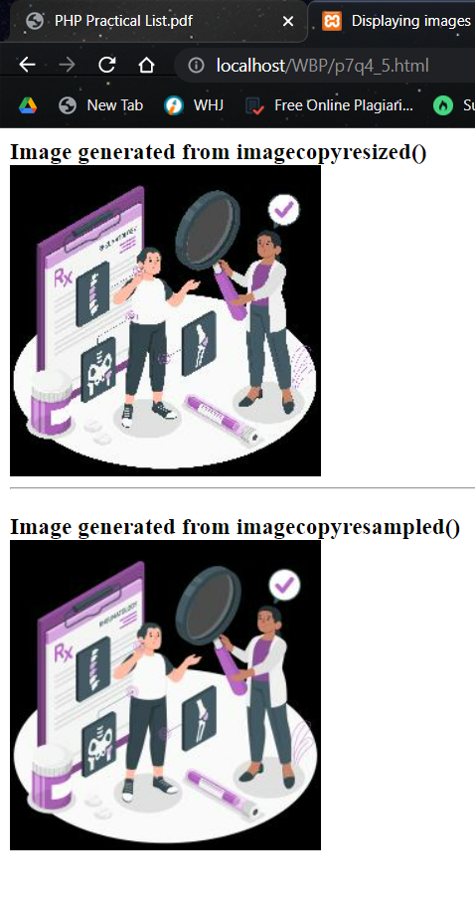

Q5

TXT:

Roll No;Name;Branch

20428;KHAN TARIQ;Computer

19301;Rahul;Electrical

19322;Kavya;Electrical

19513;Barkha;Mechanical

20111;Sakshi;Computer

PHP:

<?php

require('fpdf.php');

$pdf = new FPDF();

$pdf->AddPage();

$row = file('students.txt');

$pdf->SetFont('Arial', 'B', 13);

$pdf->Cell(90, 10, 'Student Information');

$pdf->Ln();

foreach ($row as $rowValue) {

$data = explode(';', $rowValue);

foreach ($data as $columnValue)

$pdf->Cell(60, 12, $columnValue, 1);

$pdf->SetFont('Arial', '', 12);

$pdf->Ln();

}

$pdf->Output();

?>

